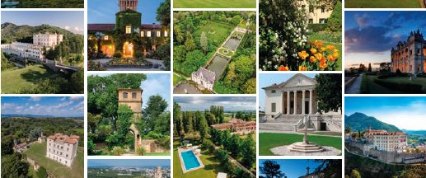
PRESS INVITATION
The press conference launching the project

VilleCastelliDimore – Timeless Moments in The Land of Venice

who will be held on

7th March 2023 at 2.30pm
at ITB Berlin - international tourism exhibition
(Veneto Region stand - Pav/Halle 1.2 - Stand 105)

VilleCastelliDimore brings together more than 30 prestigious historic locations of the Veneto region - close to Venice, Italy - representing a wide constellation of refined tourism spots that range geographically from the Po Delta to the Dolomites, from Lake Garda to the Brenta Riviera, passing through the Berici and Euganean Hills, up to the Prosecco Hills. At ITB, VilleCastelliDimore will officially present its new web portal www.villecastellidimore.com to the public and to the travel trade. This is why VilleCastelliDimore – Timeless Moments in The Land of Venice chose ITB as the first international stage to present itself to the world tourism industry as an excellence in the Italian and Venetian scenario. The story of these ancient villas, castles and houses began when Venice no longer turned its gaze towards the sea but towards the hinterland, building the Venetian Villas. VilleCastelliDimore opens the doors of different kinds of historic houses - including castles and mansions, all of them shining bright as stars in the precious sky which is the tourism industry in the Veneto region.

With interventions by:

Mr Giulio Vallortigara Valmarana, co-owner of stately home Villa Valmarana ai Nani in Vicenza, Italy and head of project
Mrs. Elena Stella, sales&marketing consultant for international markets
Moderator:
Ms. Alexandra Mattern, journalist and tourism entrepreneur

Please send your confirmation of attendance to:
press office manager Ms. Barbara Codogno, mob. +39 3495319262

